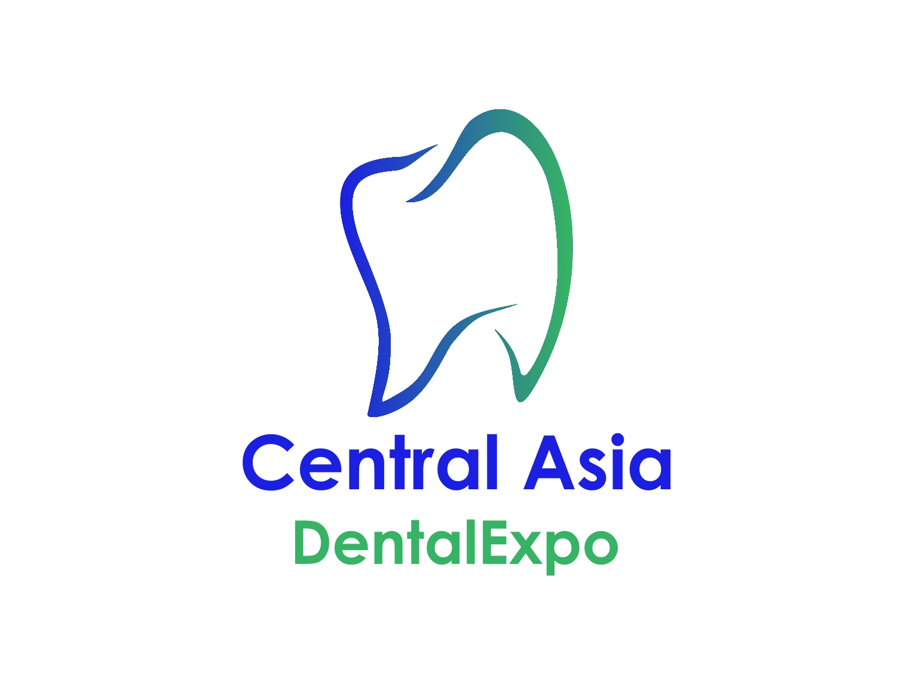1st International specialized dental exhibition CENTRAL ASIA DENTAL EXPO
CADEX-2016
November 17-19, 2016,
Almaty, Kazakhstan
APPLICATION-CONTRACT FOR PARTICIPATION AT THE FAIR –From No.2

Company name:
Contact person (Position):
Tel.: |  |  |  |  |  |  |  | e-mail:
STAND DETAILS |  |  |  |  |  |  | PRICE in USD per m2 |  |  |  | sq.m. (m2) |  |  | TOTAL
SHELL SCHEME (min.9m2): rear & side walls, carpet, 1 table, 2 chairs, waste basket, electrical connection & consumption (2 KW) , 2 spotlights, rack, fascia name |  |  |  |  |  |  | 250 USD
SPACE ONLY (min.15m2): space, general cleaning, pavilion security, without electrical connection |  |  |  |  |  |  | 210 USD
Advertising in the official exhibition catalog 1 page |  |  |  |  |  |  | 300 USD
Corner booth : +10% |  |  |  | Peninsular booth : +15% |  |  |  |  |  | Island booth : +20%
Registration Fee – 350 USD It includes : company information in the official exhibition catalogue, 1 copy of the catalogue, 4 badges, advertisement in Media, 2 invitations to the reception on the occasion of the exhibition’s official opening (for each following participant it is paid extra).
Company name on fascia board
Max 15 letters
Renting extra furniture | 1.
Renting extra furniture | 2.
Renting extra furniture | 3.
Renting extra furniture | 4.
Renting extra furniture | 5.
Renting extra furniture | 6.
Renting extra furniture | 7.
Renting extra furniture | 8.
Renting extra furniture | 9.
Total for Extra Furniture: |  |  |  |  |  |  |  |  |  |  |  |  |  |  |  | USD
GRAND TOTAL:: |  |  |  |  |  |  |  |  |  |  |  |  |  |  |  | USD
1. Hereby the Exhibitor confirms participation in the Fair, accepts “Exhibition Manual” (Form №1), and confirms that custom procedure rules of the exhibit legalization in the Republic of Kazakhstan is to be examined thoroughly.
2. Booth is reserved once 50% of prepayment of the total amount done.
3. 100% payment shall be paid in 45 days before the start of the exhibition.
4. The organizer provides all services mentioned above and paid in full.
ORGANIZER : |  |  |  |  |  |  | EXHIBITOR:
"Global Stom Industrial» LTD. |  |  |  |  |  |  | Company:
Address: 39, Hadji Mukan str, office 59 |  |  |  |  |  |  | Legal address:
Almaty, Republic of Kazakhstan
Tel. +7 707 8235367 |  |  |  |  |  |  | Tel.:
manager@cadex.kz |  |  |  |  |  |  | Website:
BIN: 13124001210 |  |  |  |  |  |  | BIN:
Account(USD) №: KZ659261802172283001 |  |  |  |  |  |  | Account:
SWIFT: KZKOKZKX |  |  |  |  |  |  | SWIFT:
Bank: JSC "Kazkommertsbank" |  |  |  |  |  |  | Bank:
« » 2016 |  |  |  |  |  |  | « » 2016
date |  |  |  |  |  |  | date
Director Aidarbekova Zh.D.
title, name & surname L.S. |  |  |  |  |  |  | title, name & surname L.S.
Originals in 2 copies to be brought to the exhibition! Before the exhibition signed facsimile or electronic copies of the documents are legally binding. Please send filled and signed application form to e-mail: manager@cadex.kz

